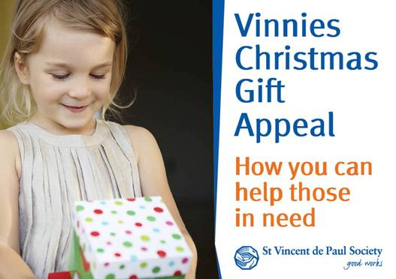

For those who may not know the Vinnie's Christmas Gift Appeal is a great Christmas drive that the St Vinnie’s run where donations are made in the form of gifts, and the gifts are distributed to local families who otherwise would not experience the full joy of Christmas.

[](http://cdn.morefm.co.nz/morefm/AM/2012/12/21/5502/Excited-Kids-Christmas-12.jpg)

Everybody should feel like this on Christmas morning.

We ask if each person could please purchase a gift and bring in by **Monday 7th December** and we will arrange for the St Vinnie’s to come and collect so as these can reach families in need by Christmas day. St Vincent’s request that the gifts are left unwrapped so please do not wrap your gift.

**In case some of you are not sure what you could purchase below are some suggestions from the Vinnie’s website.**

**For men:**

Toiletry packs (containing razors, shaving cream, shampoo, soap, deodorant, toothbrush and toothpaste), clothing vouchers, shoes, thongs, bags/backpacks and gift cards (e.g. Target, JB HiFi, Kmart, Big W, Cotton On)

**For children and teens:**

Plush toys, rattles, clothes, building blocks, books, art and craft supplies, board games, sporting equipment, movie vouchers and gift cards (e.g. Kmart, Big W, Cotton On, Typo, Smiggle, Rebel Sport)

**For women**

Toiletry packs (containing shower gel, shampoo/conditioner, body lotion, deodorant, toothbrush and toothpaste), make up kits, bags, clothing vouchers, gift cards (e.g. Kmart, Big W, Cotton On, Body Shop)

***Please keep in mind they often experience a shortage of gifts for older children/teenagers, particularly adolescent boys aged 10-16 years.***

**Don’t have time to shop?**

If you’re pressed for time or having trouble deciding what to gift why not **donate a virtual gift** and let us do the hard work for you! Details at **vinnies.org.au/virtualgift**

**Please do not wrap gifts**